Microbiology
Lab 9 Report Name ___________________

DNA Extraction and Agarose Gel Electrophoresis

Virtual DNA Extraction Interactive

1.What are three ways human DNA can be used?
Human DNA can be to test genetic diseases in newborns through study of its sequence.
DNA can be used to study genes involved in genetic diseases such as cancer.
Human DNA can help in forensic science to identify an individual through fingerprints as evidence. DNA fingerprints display a pattern band that is specific to each human being.

2. Where is DNA located? How much DNA can be found in one cell?
DNA is located in within the chromosomes found in the nucleus of each cell. The amount of DNA found in a cell differs with the organisms and exists in supercoiled nature to fit in the space. Humans approximately have three billion base pairs of DNA in a single cell.

3. What kind of cells can be used to isolate DNA?
The kind of cells used to isolate DNA depend on the reason for extraction. For instance, forensic scientists routinely use cells from hair, saliva, sperms and white blood cells as they are readily available.

4. What are the four steps to purify DNA?
The four steps to purify DNA are creating a lysis, clearing the lysis, binding to purification matrix and washing/elution. Creating lysis disrupts the cell to release nucleic acid into the lysate done using physical, chemical and enzymatic methods. Clearing lysis entails removing any cellular debris and other unwanted materials. Purification matrix such as silica and the cation exchange purify the DNA contents. Wash buffers contain alcohol to remove proteins before illusion to remove the silicon membrane.

5. What are some reagents used in the DNA purification?
The reagents used in DNA purification are isopropanol and high concentration salt solutions.

6. What is the purpose of the lysis solution?
Lysis solution rapidly disrupts the cells to release nucleic acid which contains the required DNA for purification.

7. What is the purpose of the salt solution?
The salt solution precipitates the cell debris and proteins by causing a fall out of solution.

8. What can you do with DNA once it is extracted from a cell?
Extracted DNA can be used in PCR and genome sequencing to modify organisms.

Virtual Gel Electrophoresis

Refection on DNA and forensics
The article focuses on the significance of DNA in forensic analysis which aids in making court decisions. Forensic analysis works on the principal that blood related people have similar DNA bases. DNA profiling entails the used of DNA sequence to identify an individual during investigation. The DNA sequence acts as evidence to confirm individuals suspected to be involved in a certain crime. The individual is confirmed when the bases collected from the crime sample match the DNA of an individual. DNA profiling aids in ruling parenting-related cases in the court. The three billion DNA base pairs in unrelated people are completely different but closely similar in related people. The matching base pairs show that people are likely to be related which helps in making court decisions.

Answer the following questions on agarose gel electrophoresis:

1. What three properties of molecules are used to separate them using agarose gel electrophoresis?
The three properties of molecules are size, charge and conformation. The size of molecules helps to separate the charge sized molecules such as proteins from small sized molecules. Charges allow the molecules to move in the electrical field. Conformation involves the capability of a molecule to change shape during electrophoresis.

2. Explain why DNA normally moves toward the positive electrode during electrophoresis.
DNA normally moves toward the positive because it is negatively charged. Negatively charged molecules of DNA move towards the positively charged electrode along the electromagnetic field of electrophoresis.

3. If a mixture of different size DNA fragments is placed into the well of an agarose gel and a current is applied, what will happen? Explain why.
The larger sized DNA fragments move slower than the smaller molecules to create band patterns in the gel matrix. The currents cause molecules to move through the matrix towards the oppositely charged electrode. The large molecules are slow and require a higher current to move at the same speed with the small molecules.

4. What is the purpose of the agarose?
The purpose of the agarose is to separate DNA fragments based on the different sizes. Agarose is the content in the gel that determines stiffness based on the concentration.

5. Why is glycerol added to samples before they are loaded into the wells? Why is this important?
Glycerol is added to increase the density of the samples higher than that of water. The increased density allows the sample to layer at the bottom of the gel matrix for effective separation. Glycerol also cast gradient gels which ensures that the samples sink through the buffer and settles in the well.

6. The following picture shows the DNA electrophoresis of samples A, B, C run along with the bp ladder markers which show the relative position of the markers in the gel.
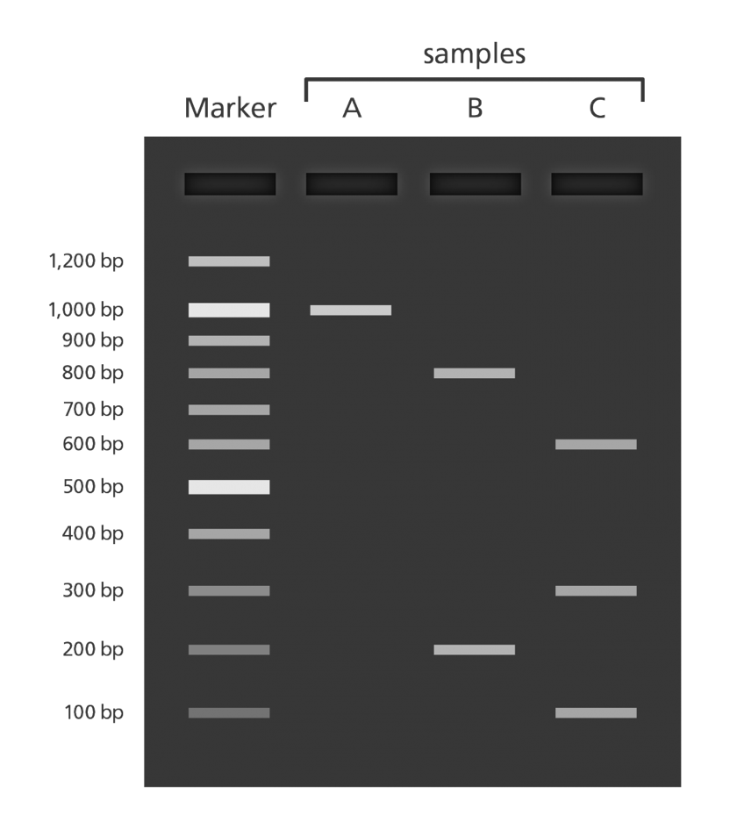

For the gel shown above which is the positive side of the gel?
The bottom side is positive.

7. For samples A, B, and C indicate the sizes of the DNA bands

Sample A: 1000 base pairs

Sample B: 800 base pairs

Sample C: 600 base pairs
8. Draw the movement of the following on this gel, take a picture and insert the picture back in this document.

been applied. Lane 1 2 3 4
Size Charge +

Lane 1: Protein A 34,000 daltons +
Lane 2: Protein B 67,000 daltons +
Lane 3: Protein C 13,000 daltons +
Lane 4: Protein D 13,700 daltons -

Add your picture here:
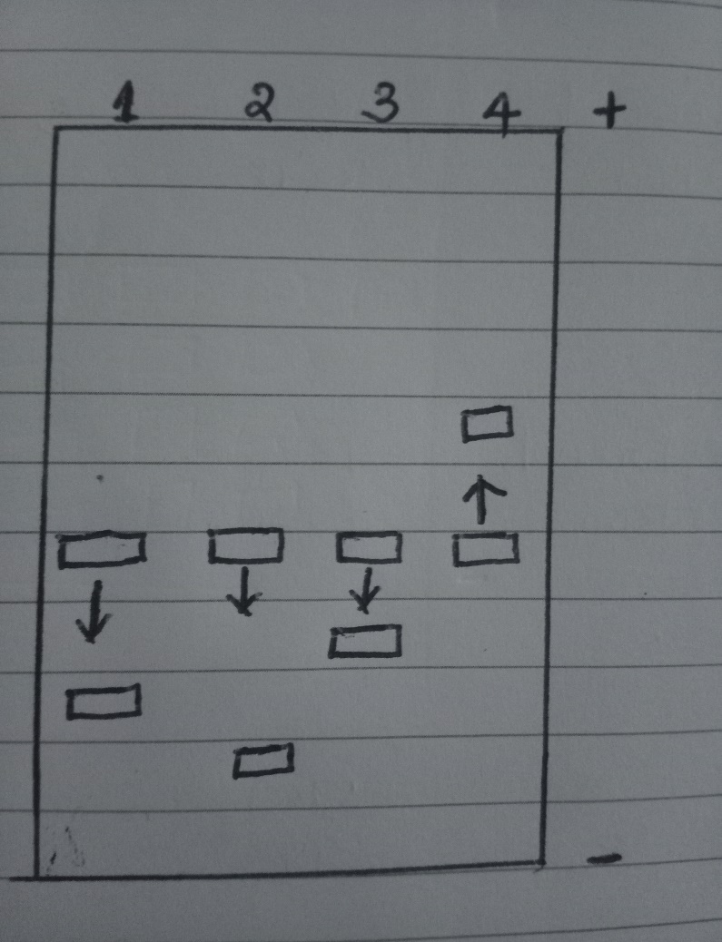
9. Can DNA demand a verdict? Write your reflection and take away from this article below
DNA can demand a verdict because it provides evidence enough to make a court or legal decision. DNA profiling entails the use of DNA to identify an individual and accounts for 99% accuracy. Forensics use DNA profiling to identify suspects in a crime and use the evidence to make a legal ruling is a verdict. The three billion base pairs of DNA are different for people that are not related by blood. The article identifies the significance of the DNA bases pairs in profiling and identification.

Works Cited
Kaufmann, M. E., and T. L. Pitt. "Pulsed-field gel electrophoresis of bacterial DNA." Methods in practical laboratory bacteriology. CRC Press, 2018. 83-92.
Wittmeyer, Jacqui. "Can DNA demand a verdict." (2004).

